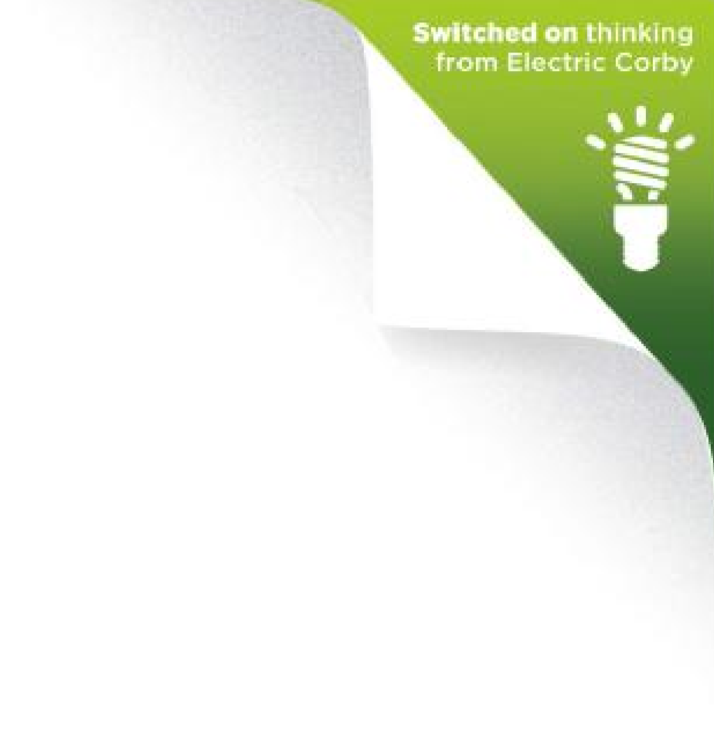

Environmental Policy
We are committed to delivering a greener, sustainable future for the people of Corby. Whilst doing this we are also committed to ensuring our own operations have the minimum negative effect on the environment.
Commitments

- Increase the use of green electricity in the borough of Corby.
- Minimise energy use wherever possible.
- Continual improvement on environmental issues where economically feasible.
- Control the activities of the company to minimise risk of pollution to the environment.
- Minimise the production of waste where possible and any disposal of waste produced will be carried out with due care for the environment.
- Minimise the use of new products where other recycled materials are a suitable substitute.
- Make every effort to ensure that where waste materials or products can be recycled they are recycled in an environmentally responsible way in order to conserve resources.
- Ensure that our operations comply with or exceed current legislation and other relevant requirements.
- Be a responsible employer and neighbour.
- Ensure that all employees carry out their duties in line with the above statement and, through training, are aware of their obligations.
- Refresh and keep publicly available our Environmental Policy on our website.

Actions

Work with our landlord/building manager to reduce and procure green energy
- Use electronic means of media before printing, and where we print reuse paper before recycling
- Switch off and monitor electronic use in our space and the centre as a whole. Minimising equipment and lighting use as much as possible. We will use low energy lighting and A rated appliances wherever possible
- We use non-disposable catering equipment from onsite caterers
- We will keep the use of water to a minimum and not procure spring water
- We recycle our printer cartridges, batteries and compost our kitchen waste
- We use public transport, electric vehicles or car share, wherever possible and practical and we make use of conference calls, Skype and other digital means to reduce the need for travel to meetings

This policy will be reviewed annually as part of the organisation overall environment management plan. For further information contact info@electriccorby.co.uk

